Walenstadt/Zurich, February 6, 2020

Press release

“Quartierstrom” – field test of Switzerland’s first local electricity market successfully completed

For one year, 37 households in Walenstadt have sold solar power in a local blockchain-based electricity market. The participants involved in this pioneering project, the first of its kind in the world, were very positive about their experience. As expected, the system led to a substantial increase in self-consumption and self-generated supply. The participants played an active role in the electricity market but were reluctant to pay more for locally produced power.

Switzerland’s first local electricity market has successfully completed field testing in January 2020. For one year, 37 households in Walenstadt traded locally produced solar power within their own neighborhood. Participants could directly buy and sell solar power within their neighborhood via a portal on which the participants could set their own purchase and sales price limits for solar power. The resulting transactions were processed automatically via a blockchain. The local electricity supplier, Water and Electricity Works Walenstadt (WEW), not only provided access to its distribution grid but also purchased surplus solar power and supplied the community with “normal” power when the supply of solar power was insufficient. This innovative project, which is supported by the Swiss Federal Office of Energy (SFOE) as a flagship project, aimed not only to verify technical feasibility in the field but also to study user behavior.

Significantly higher consumption of local solar power
After a year in the field, project participants from research and industry give a positive appraisal. Thanks to the local electricity market, the local community the purchase of the of the locally produced solar power almost doubled. The 37 households covered 33% of their electricity demand with solar power produced in the neighborhood – twice as much as beforehand. These figures might have been anticipated, but it was surprising how well the project was received. The participating households played a very active role and perceived the electricity market as green, local, and fair. “After initial skepticism, even the energy industry has shown a great deal of interest and sees a lot of potential in the development. We’ve managed to really provoke discussion,” says Christian Dürr, Managing Director of the Water and Electricity Works Walenstadt. Verena Tiefenbeck, leader of the Bits to Energy Lab at ETH Zurich, also gives a positive appraisal: “Quartierstrom was the first project of its kind in the world, and we did pioneering work on many different fronts. We’re especially delighted that the technology operated effectively – apart from the usual teething troubles.” For the Swiss Federal Office of Energy, the application of these new technologies was a particular area of interest. “The project allowed us to study the extent to which blockchain and artificial intelligence might be suitable for the direct marketing of electricity from decentralized energy sources and what role the energy supplier plays in a bottom-up approach of this kind. These findings should be helpful for the future development of the electricity market,” says Benoît Revaz, Director of the SFOE.

Almost no one wants to pay more
One new feature of the system was that participants could use a portal to set a minimum sales price for their solar power and a maximum purchase price to buy solar power from their neighbors. “The participants frequently adjusted the price limits, especially at the beginning. But the price limit they set for buying local solar power was rarely higher than for normal power from the grid,” says Tiefenbeck. On average, the participants were willing to pay just under 19 centimes per kilowatt hour – less than the cost of mains power, which stands at 20.75 centimes. Fewer than 10% of offers were above this rate, despite the fact that many people had declared their willingness to pay more for local solar electricity in the surveys conducted beforehand. “This gap between attitude and action is seen in behavioral research time and time again,” says Tiefenbeck. The researchers also attribute this to the fact that the participating households knew that local solar power was subject to lower grid fees and that, accordingly, the power suppliers were getting more for their power, even at lower prices. For their part, the households with solar power systems also sought to make a profit, asking for around 7 centimes per kilowatt hour. When selling to the power plant they made only 4 centimes.

Automatic pricing is more effective
In order to compare different market models, the researchers deactivated the feature allowing individual pricing for a period of one month and replaced it with an automatic pricing system. When demand and production coincided, the solar power was distributed locally. The price varied automatically depending on whether the solar power was in relatively scarce supply or in surplus. With individual pricing, on the other hand, a small proportion of the solar power could not be sold because the price requirements of suppliers and consumers did not match. In surveys, a little over half of households stated that they preferred automatic pricing. “What was surprising was that participants who used the portal frequently tended toward automatic pricing and vice versa,” says Tiefenbeck. “Based on our experiences, we don’t consider individual pricing to be decisive for a local electricity market in the future.”

Effectively raising awareness
What does seem to be important, on the other hand, is that participants are able to monitor production and consumption, as well as their purchases and sales, in real time. This function was very popular with users and contributed to raising awareness. Indeed, many participants said that they now use electrical appliances more when the sun is shining. They saw the peak and off-peak tariff system that still applies today as outdated when applied to renewable energies. Christian Dürr: “The participants developed an understanding of the energy market, thereby helping to balance supply and demand. This reduces the burden on the infrastructure and puts surplus power to sensible use.”

Reliable software but a need for hardware optimization
While the software proved highly reliable, the project team repeatedly struggled with hardware failures. As there was no smart meter with an application processor available on the market, the project team had to use devices (Raspberry Pis) with self-developed modules instead. “These devices have an error-prone, SD-card memory system,” says Arne Meeuw, who developed the blockchain system. For larger applications, projects like “Quartierstrom” would require certified and stable smart meters with an integrated application processor that could run different software tools.
The blockchain system, on the other hand, proved highly robust – although its capacity was limited. Twenty-seven prosumers acted as validator nodes to approve the transactions in the blockchain. These nodes represent the critical variable when it comes to scaling. “The system could still handle about five more solar installations,” says Meeuw. The number of consumers could be increased further, on the other hand, and the system would remain stable with up to 600 pure consumers or other clients, such as batteries or flexible loads. “It would be possible to scale the system up by building multiple blockchains for different neighborhoods,” says Meeuw. In turn, these could then exchange electricity between themselves.

Low power consumption
Unlike public blockchains, such as those used for Bitcoin, the Quartierstrom blockchain is private. Moreover, the approval of transactions does not rely on elaborate computational processes. “The nodes reach an agreement on a proposed energy trade,” says Meeuw. This mechanism doesn’t require a great deal of computing power. The small computers that are used as smart meters and blockchain nodes consumed around 3,300 kilowatt hours of energy over the duration of the project. In terms of the volume of power traded in the local market, this consumption amounted to around 4%.

Follow-up project in the pipeline
The pilot phase of the local electricity market as part of the SFOE flagship project has now come to an end. However, a follow-up project has been launched to ensure a seamless transition, albeit in modified form. The user portal has been redesigned and streamlined slightly, and prices are now set automatically. In the coming months, the hardware will gradually be replaced with series-produced equipment, and there are also plans to develop the trading platform into a marketable product. This aim is being pursued by the spin-off “Exnaton”, which was founded by members of the development team at ETH Zurich. One option under development would allow participants to determine their preferred suppliers of local solar power, rather than setting prices. In other words, they could choose to buy electricity from their aunt’s roof or from the farmer who sells them their eggs. After all, “Quartierstrom” has also demonstrated that emotion plays an even bigger role in a local market than price.

Further information:
www.quartier-strom.ch: Background information, the latest news on the project, and live data on electricity production and consumption, as well as self-consumption and self-generated supply within the Quartierstrom community.

Media contact Contact for technical queries
medien@quartier-strom.ch kontakt@quartier-strom.ch
Sara Blaser Verena Tiefenbeck
+41 (0)44 545 05 00 Bits to Energy Lab, ETH Zürich
Sprachwerk GmbH Tel. +49 911 5302 96412
www.sprachwerk.ch

Project participants
The “Quartierstrom” project is supported by the Swiss Federal Office of Energy (SFOE) as part of the “Pilot, demonstration and flagship projects” program. At the heart of the project was a close collaboration between a broad-based consortium of research and industry.

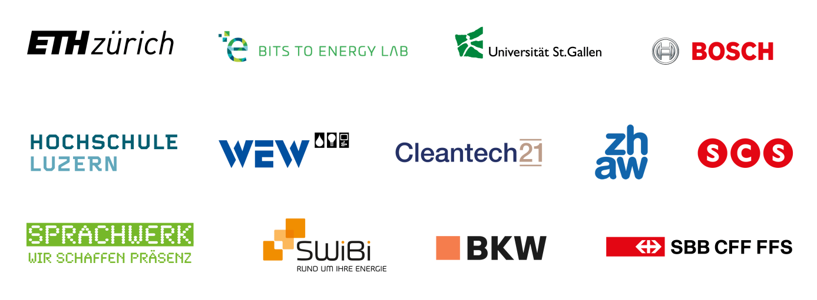

The “Quartierstrom” project – how does the local electricity market work?
The basic idea of the Quartierstrom project is for locally produced solar power to be consumed locally. In this local electricity market, local residents buy and sell solar power among themselves. The solar power is consumed in the prosumers’ own households first of all; only the surplus is traded within the neighborhood. If the solar power systems produce more electricity than the community is currently using, the Water and Electricity Works Walenstadt (WEW) buys up this surplus power. Conversely, the power company supplies additional power if local production is insufficient.
The buying and selling of solar power are managed directly between the participants themselves via a portal on which the producers can set the minimum price for their solar power. At the same time, the consumers define the maximum price they are willing to pay for local power. The resulting transaction is processed automatically via a blockchain. All participating households have a mini computer installed with a built-in electricity meter and blockchain software. Based on the individual price settings, these blockchain nodes then place quarter-hourly bids for the purchase or sale of solar power and use an auctioning mechanism to calculate whose bid is accepted at which price.

Photos and Diagrams

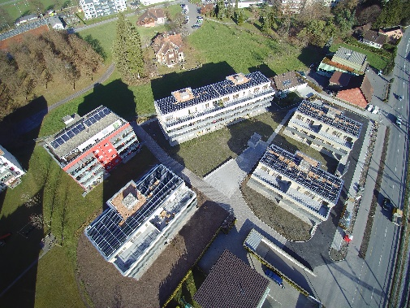
Positive experience: For one year, 37 households in Walenstadt traded solar power in a local electricity market based on a block chain. (© WEW)

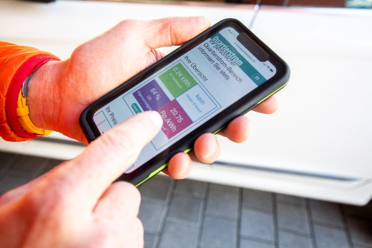
On the “Quartierstrom” app, consumers can observe in real time how much solar power they buy from the neighbourhood. (© Gian Vaitl)

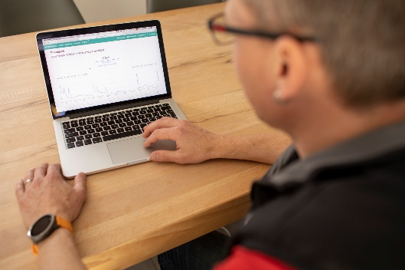
On the “Quartierstrom” portal, the participants can set their prices and observe the data of the electricity market. (© Gian Vaitl)

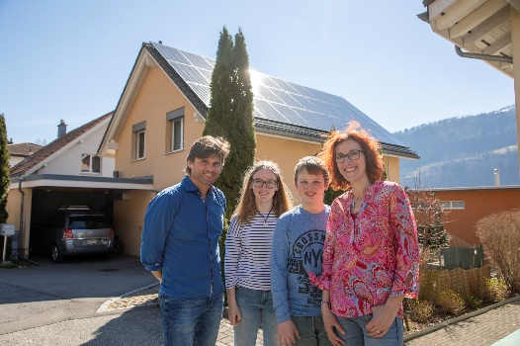
The Hässig family is one of 37 households participating in the local electricity market. (© Gian Vaitl)

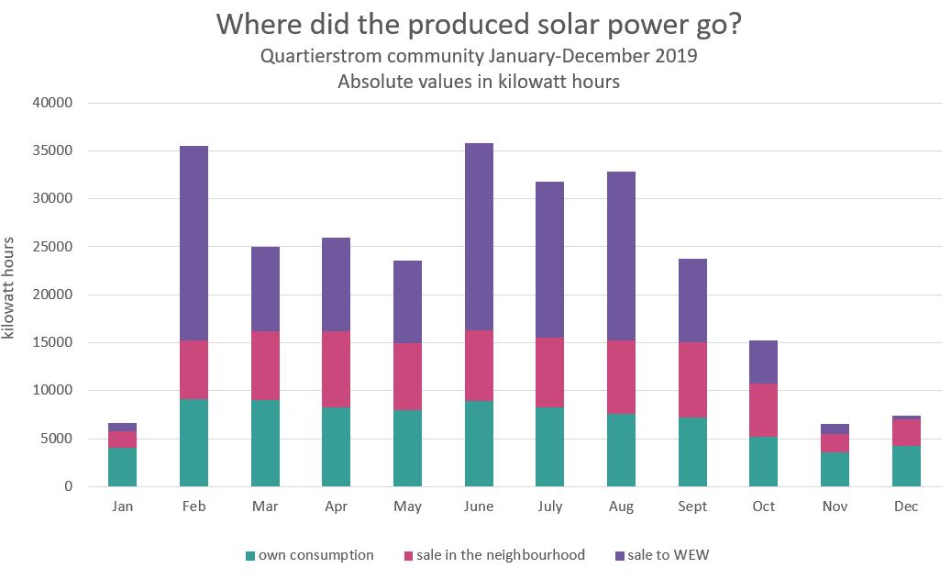
In absolute terms, own consumption in the producers' households and the electricity sold in the neighbourhood were of a similar magnitude over the entire pilot phase – except when demand could not be met because production was too low. (© www.quarteri-strom.ch)

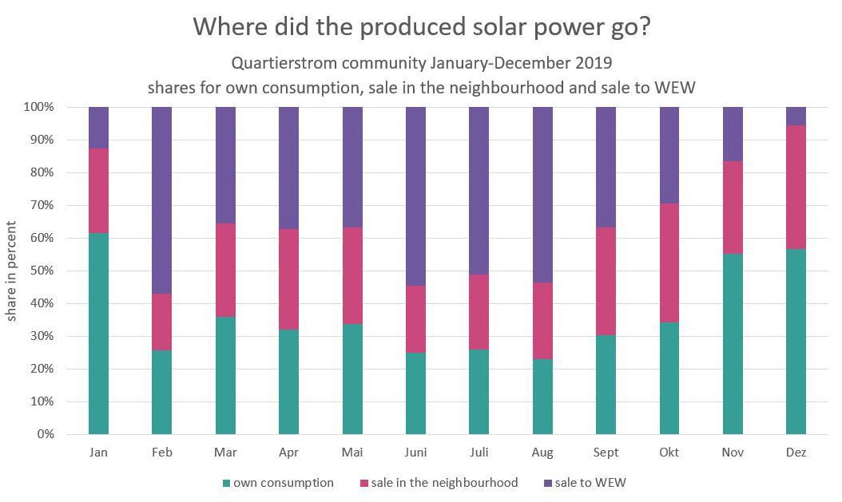
In relative terms, own consumption decreased with high electricity production. Over the year, self consumtion in the Community as a whole was almost doubled. (© www.quarteri-strom.ch)

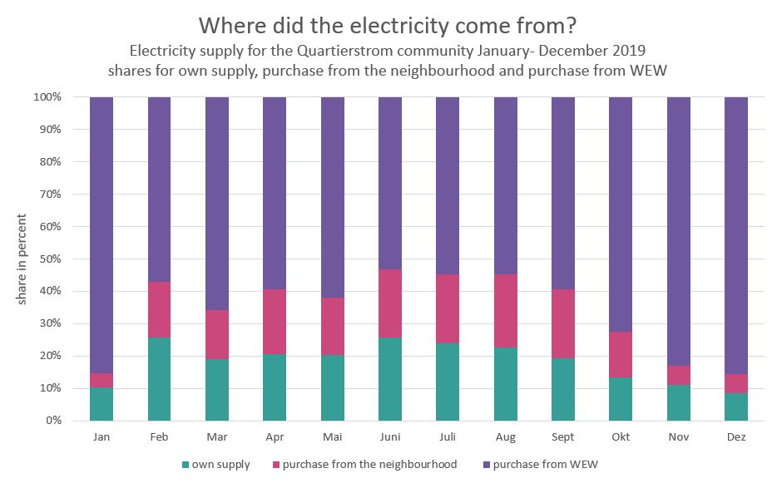
On average, the neighbourhood electricity community was able to supply itself to one third of its needs. As expected, the WEW delivers the most electricity in winter. (© www.quarteri-strom.ch)

